PROJECT REPORT
BELRAETHA LTD
SALES PERFORMANCE AND CUSTOMER BEHAVIOUR ANALYSIS
AN SQL SERVER BASED ON HISTORICAL ORDER DATA

PREPARED BY: OGBONDA, MIRACLE CHIZIM

PROGRAMME: DATA ANALYTICS

INSTITUTION: DITS ACADEMY

BATCH: L

FACILITATORS NAME: MR EXCEL AKAR

DATE OF SUBMISSION: NOVEMBER 2026

1. PROJECT OVERVIEW
This project focuses on analysing an Orders dataset using SQL. The purpose of the analysis is to understand Belraetha Ltd sales and profit performance, identify top-performing regions and product categories, and examine customer purchasing patterns.
The analysis uses SQL queries to extract useful information from the dataset and provide insights that can support better business decisions.

2. BUSINESS OBJECTIVES
The main objectives of this project are to:
- Understand the overall sales and profit performance.

- Identify the region with the highest sales and profit.

- Analyse the performance of different product categories.

- Calculate average sales across customer segments.

- Identify orders with sales above $1,000.

- Find the five most profitable product sub-categories.

- Identify product categories generating more than $10,000 in profit.

3. DATASET DESCRIPTION
The dataset used for this project is the Orders dataset. It contains sales transaction records and information about customers, products, orders and geographical regions.
The dataset includes important columns such as Order ID, Order Date, Customer Segment, Region, Category, Sub-Category, Sales and Profit.
These columns provide the information needed to analyse sales performance, profitability and customer purchasing patterns.

4. TOOLS USED
The following tools were used for this project:
Microsoft SQL Server – Used to write and execute SQL queries, retrieve data and perform analysis.
Microsoft Excel– Used to organise, review and validate the dataset, as well as support basic data checks and verify analysis results.

5. DATA CLEANING AND PREPARATION
Before starting the analysis, the dataset was reviewed to understand its structure and check the available columns.
The first 10 records were retrieved to examine the dataset and understand the information it contained.
The dataset was checked for completeness, and the expected columns were present. The initial review did not reveal any obvious missing data that required correction.
The dataset was then used for the SQL analysis.

6. SQL ANALYSIS AND KEY FINDINGS
Business Question 1: Data overview
The following business questions were answered using SQL queries.
Objective: To Retrieve the first 10 records
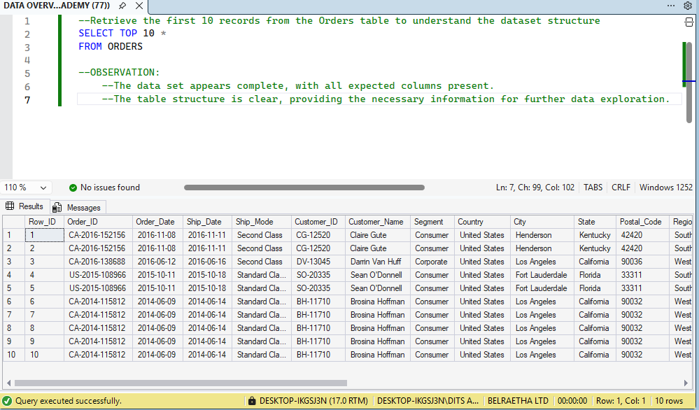

Observation:
The first 10 records were retrieved successfully. The dataset contained the expected columns needed for the analysis.

Business Question 2: Overall Business Performance
Objective: To Calculate Total Sales and Total Profit
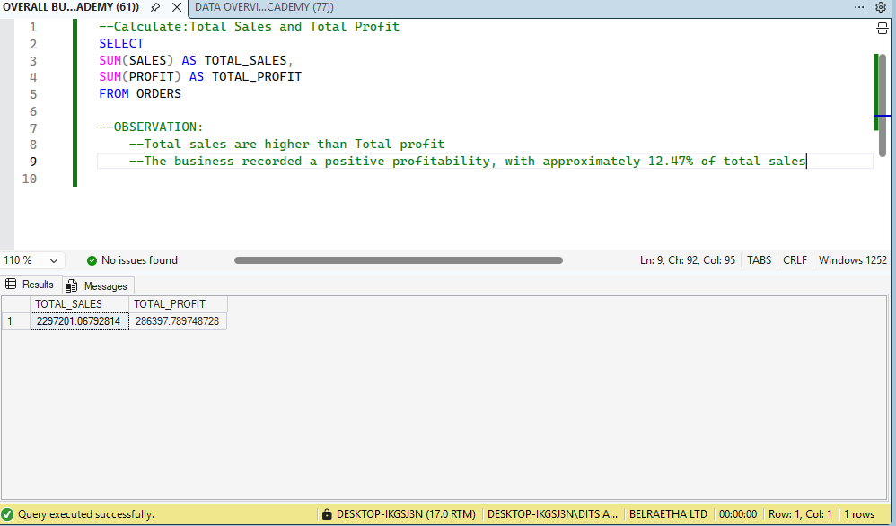
Observation:
The business generated total sales of $2,297,201.07 and a total profit of $286,397.79 during the period covered by the dataset.

Business Question 3: Regional Performance
Objective: To Determine the Region with the Highest Performance
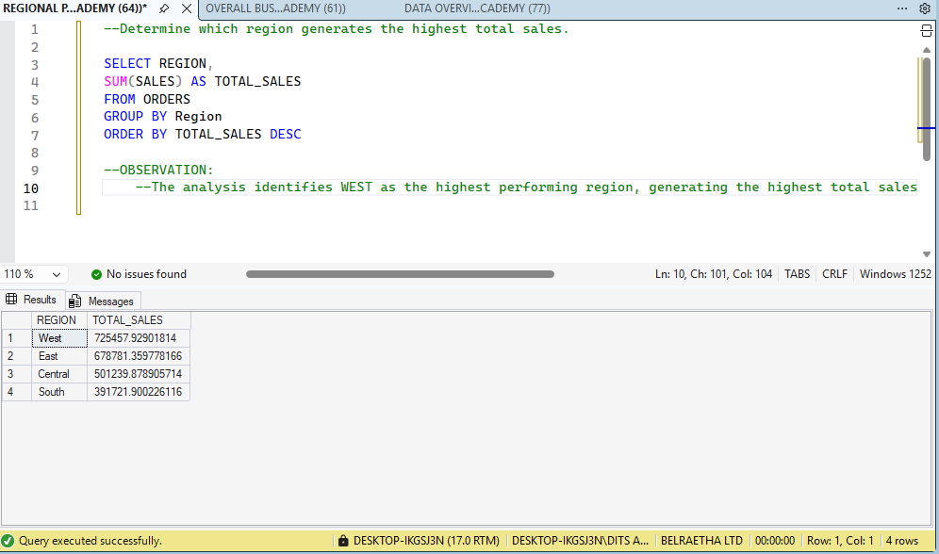
Observation:
The query compares sales and profit across different regions to identify the region with the strongest sales performance.
Highest-performing region: WEST

Business Question 4: Product Category Performance
Objective: To Analyse Product Category Performance
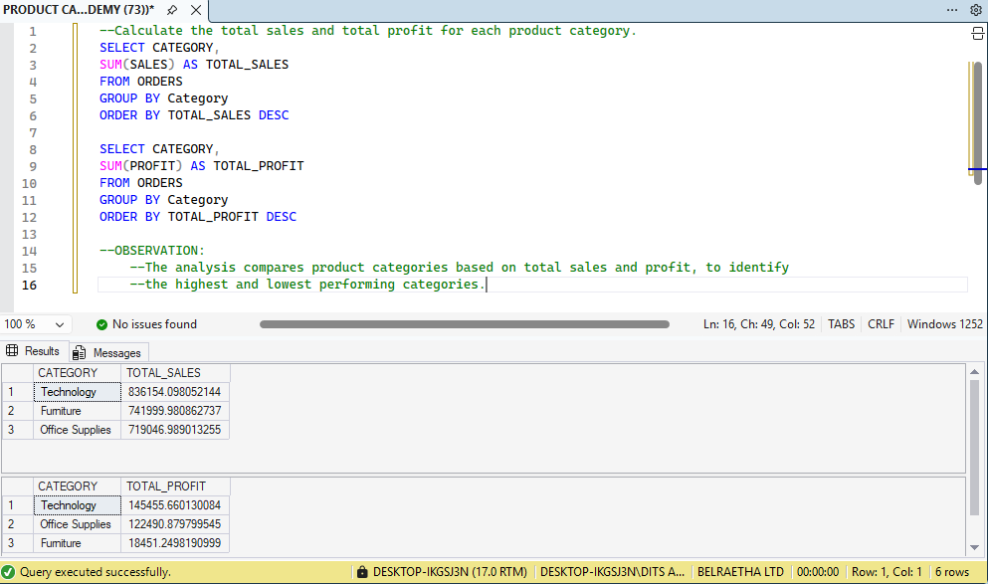
Observation:
The analysis compares the total sales and profit generated by each product category. This helps identify the highest and the lowest performing categories.

Business Question 5: Customer Segment Analysis
Objective: To Calculate Average Sales per Customer Segment
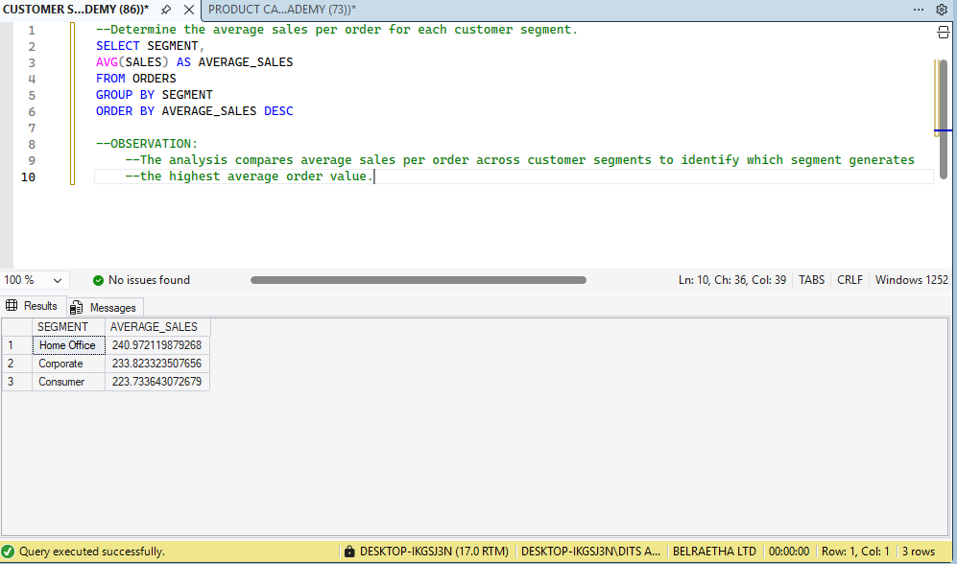
Observation:
The query calculates the average sales for each customer segment, helping the business understand purchasing patterns across its different customer groups.

Business Question 6: High-value Orders
Objective: To Identify Orders with Sales Greater Than $1,000
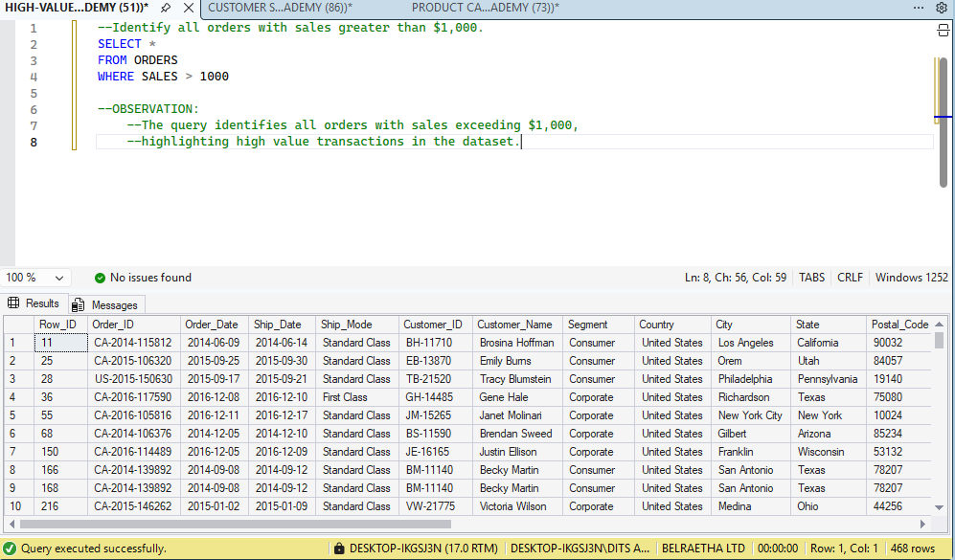
Observation:
The query successfully identifies orders with sales above $1,000. These records represent high-value transactions that can be examined further.

Business Question 7: Product Profitability
Objective: Identify the Top Five Most Profitable Product Sub-Categories
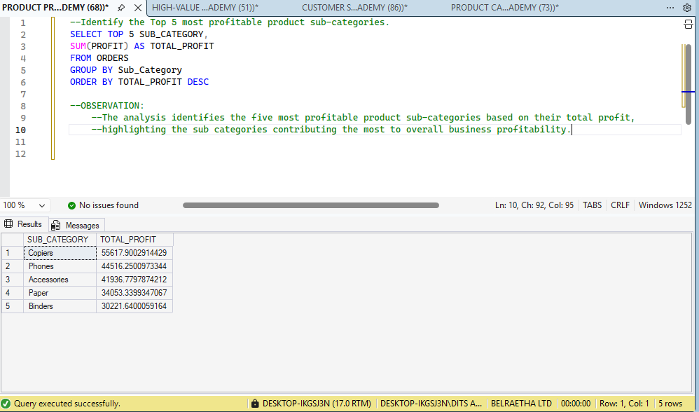
Observation:
The analysis identifies the five product sub-categories that contribute the highest total profit, providing insight into the most profitable products.

Business Question 8: Profitability Threshold
Objective: Identify Product Categories with Total Profit Above $10,000
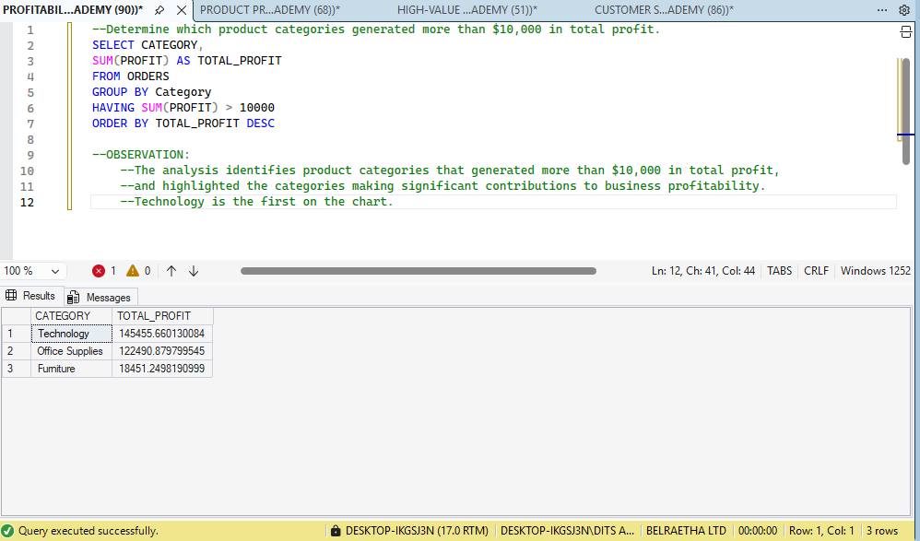
Observation:
The query identifies product categories that generated more than $10,000 in total profit. This helps highlight categories with strong profit contributions.

7. BUSINESS INSIGHTS
The analysis revealed the following:
- The business generated over $2.2 million in total sales and approximately $286,397.79 in profit.
- Regional analysis helps identify locations contributing more to sales and profit.
- Product category analysis provides information about which products contribute most to business revenue.
- Customer segment analysis helps the business understand differences in customer purchasing patterns.
- High-value orders provide opportunities to identify and understand valuable transactions.
- The top five profitable sub-categories reveal products that contribute significantly to overall profit.
Overall, the analysis provides a better understanding of the company's business performance and areas that require attention.

8. RECOMMENDATIONS
Based on the analysis, management should consider the following practical actions:
- Improve Regional Sales Report: Management should identify regions with lower sales and profit and investigate the factors affecting their performance. The company can introduce targeted marketing campaigns, promotional offers and better distribution strategies to improve sales in these regions. The regional analysis will help management focus on areas with the greatest opportunities for growth.
- Focus on Profitable Products Categories: Maintain adequate stock and increase promotions for product categories and sub-categories generating higher profits.
Management should consider investing more in its high-performing Technology category while reviewing the pricing and costs of the Furniture category to improve profitability.
- Promote the Most Profitable Sub-Categories: Management should prioritise the five most profitable product sub-categories identified in the analysis. These products can receive more marketing attention, better stock management and attractive promotional offers to maintain their profitability and increase revenue.
- Improve Customer Retention: The company can develop targeted marketing campaigns, personalised offers and loyalty programmes to encourage repeat purchases. Use customer segment results to develop loyalty programmes and targeted offers that encourage repeat purchases.
- Monitor High-Value Orders: Orders with sales above $1,000 should receive proper attention. Management can study these transactions to understand the products, customers and purchasing patterns responsible for high-value sales. This information can help the company develop strategies to attract more high-value customers and encourage larger purchases.
- Maintain Regular Sales and Profit Monitoring: The analysis shows that the company generated total sales of $2,297,201.07 and total profit of $286,397.79. Management should regularly monitor these figures to measure business performance, identify changes in profitability and make timely decisions when sales or profit decline.
- Improve Profitability Through Cost Management: Since total sales are higher than total profit, management should review product costs, operating expenses and pricing strategies. This will help identify opportunities to reduce unnecessary costs and improve profit margins without negatively affecting customer demand.

